TEMPLATE AND AUTHOR INSTRUCTIONS FOR TWO-PAGE ABSTRACT SUBMISSION FOR THE ERICA-CASH II FINAL CONFERENCE
Erika Mueller¹, Jane Cascati^{2*}, Paula Linde³, …
ABSTRACT: This document provides instructions for authors writing both the two-page abstract for the ERICA-CASH II Final Conference. When preparing the extended abstract, please include here your previously submitted abstract not shorter than 100 and not longer than 150 words. The abstract should present a concise statement of the scope, principal findings, and conclusions of the two-page abstract.

INTRODUCTION
Enter text of introduction here.

GENERAL INSTRUCTIONS
Enter text of section 2 here.

SUB-CHAPTER TITLE
The total length of the abstract (including figures, references, acknowledgements etc.) is 2 pages.

LANGUAGE
The text including tables and figures must be written in English. If it is not possible to modify the language in some figures (e.g. in titles or legend), please give the translation in English in the figure caption.

FONTS
The standard font type is Times (New) Roman for all titles, text, captions of figures, and tables. Paper title and all section titles are using bold fonts. The title and the first and second level section titles are written in capitals. The titles for third level sections is written with only the first letter capitalized. The font size for the body text is 10 pt.

TITLES, AUTHORS, ABSTRACT AND KEY WORDS

ABSTRACT TITLE
The paper title must be justified, using a 14 point size bold font, using capitals. Use single line spacing and do not exceed three lines.

AUTHORS AND AFFILIATIONS

Authors
Authors must be listed under the title. Type the name of the authors: first name and last name. The names of the authors must be left justified, using a 12 point size bold font. Use single line spacing. Please mark the presenter by including an asterisk*.

Affiliations
Enter text in the footnotes below the left column in the first page, following the layout as given in this example. The affiliations must be left justified, using a 9 point size font. Use normal (not bold) font and single line spacing. Affiliation must contain the name of the university/ organisation and corresponding author’s email address.

ABSTRACTS AND KEY WORDS

Abstract
Leave 30 pt between authors and abstract. The abstract starts with the word ‘ABSTRACT:’ in 10 pt bold capital letters. The remaining text must use a 10 point normal font.

MAIN TEXT

HEADINGS
Primary headings are typed in bold capital letters (12 pt), preceded by Arabic numbers (1, 2, 3, . . . ). They are left justified and the number is followed by a tabulation of 5 mm.
Secondary headings are typed in 10 pt bold capital letters, preceded by Arabic numbers (1.1, 1.2, 1.3, . . . ). They are left justified and the number is followed by a tabulation the size of which is 8 mm. Leave a 10 pt vertical space before and a 5 pt vertical space after secondary headings.
Tertiary headings can also be used if necessary. They are typed in 10 pt bold lowercase letters (first letter capitalized), preceded by Arabic numbers (1.1.1, 1.1.2, 1.1.3, . . . ). They are left justified and the number is followed by a tabulation the size of which is 11 mm. Leave a 10 pt vertical space before tertiary headings and none after.

PLAIN TEXT
The plain text is written using Times New Roman 10 pt size font with single line spacing. Paragraphs must be left and right justified and not indented. Vertical space between paragraphs is stretchable (adapted between 0 pt and 10 pt to align contents on a page).
For mathematical scalar parameters italic letters are recommended. For example, use sin x instead of sinx, sin(x) or sin x. Note that for mathematical operators such as sin, cos, log, max, . . . ) an upright font is used. In numerical expressions, decimal separator is the dot.

FIGURES
Figures must be numbered and captioned below. The caption is left justified, in Times New Roman 9 pt italic (slanted) font. The phrase ‘Figure x:’ is printed in bold font, the rest of the figure caption in normal font. Figures must be separated by blank lines (10 pt) above and 6 pt below (between the figure and its caption). Leave also 10 pt after the caption.

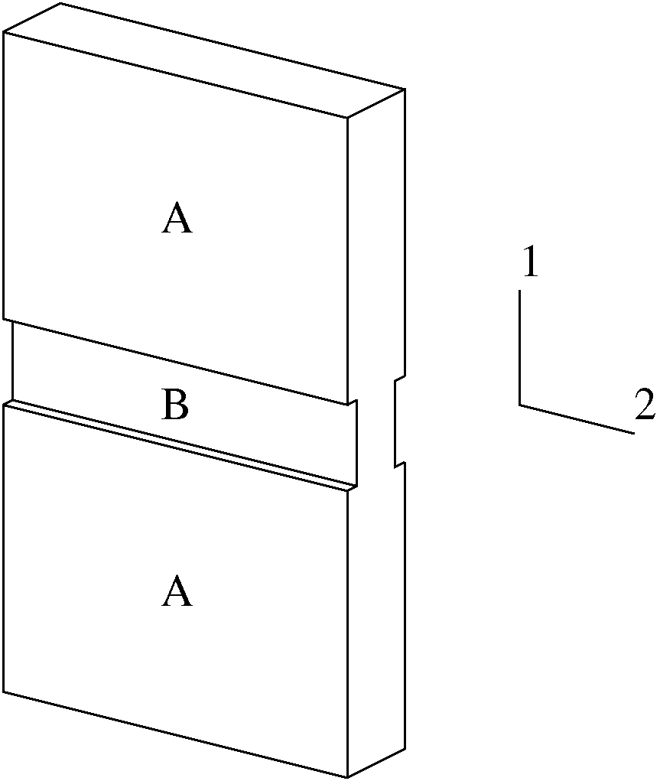
Figure 1: Analysis model
Refer to figures in the text using the whole word, for example the model is shown in Figure 1. Make sure that legends in figures are of appropriate size, also when resized to the column width as e.g. in Figure 2.

TABLES
Table captions must be specified above the table. All tables must be numbered. Use Times New Roman 9 pt italic (slanted) font for the caption and Times for the table itself. The phrase ‘Table x:’ is printed in bold font, the rest of the table caption in normal font. Leave one blank line (10 pt) before the caption and one after the table.
Use borders to clearly separate the title row form the rest.

Table 1: Margin settings
Margin | Size (mm)
Top | 25
Bottom | 18
Left | 20
Right | 20
Column width | 81
Column spacing | 8

EQUATIONS
Equations are centered and numbered between parentheses on the right of the line. Leave 6 pt before and after each equation. Refer in the text to the equation using this number placed between parentheses: see for example Equation (1) below:
(1)
where σ = stress, ε = strain, E = Young’s modulus and ν = Poisson’s coefficient.
Small equations without reference can be put in the text
directly, like a = c/d, but it should be avoided that the line space has to be stretched like in . In that case a separate equation should be added, at choice with or without number.

REFERENCES IN THE TEXT
The bibliography should be the last section of the paper and use the layout as given in this example. Use an unnumbered heading ‘References’ in the primary heading format. The references should be labelled in the order in which they appear in the text. The references are only left justified (ragged right margin).
Place references in the text using a number or a list of numbers between square brackets. Use commas and ranges, e.g. [1–3, 5].

CONCLUSIONS
Conclusions should briefly state the author’s viewpoint over the problem and the most important propositions. They can also include the perspectives for new developments as well as for new applications from the results.

ACKNOWLEDGEMENT
Enter acknowledgements directly before the references. Use the format of primary section headers, but do not number the acknowledgement and references sections.

REFERENCES
- Bathe K.-J.: Finite-Elemente-Methoden. Springer-Verlag Berlin Heidelberg New York, 2002.
- R. Mahnken. A Newton-multigrid algorithm for elasto-plastic/viscoplastic problems. Comp. Mechs., 15:408-425, 1995.
- H. Vegter, Y. An, H. H. Pijlman, B. D. Carleer, and J. Huétink. Advanced material models in simulation of sheet forming processes and prediction of forming limits. In First ESAFORM Conference on Material Forming, pages 499–502, 1998.
- M. H. A. Bonte, A. H. van den Boogaard, and J. Huétink. A metamodel based optimisation algorithm for metal forming processes. In D. Banabic, editor, Advanced Methods in Material Forming, pages 55–72. Springer Verlag, Heidelberg, Germany, 2007.

Erika Mueller, Vienna University of Technology, e.mueller@test.ac.at
Jane Cascati, Universidad de Rothko, Chile, j.cascati@test.cl
Paula Linde, UPC, USA, paula.linde@test.edu

